BANK LOAN REPORT QUERY DOCUMENT

1. BANK REPORT|SUMMARY

KPI’S:

Total loan applications

select count(id) AS Total_loan_applications from bank_loan_data



Month to date total loan applications

select count(id) AS MTD_Total_loan_applications from bank_loan_data

where month(issue_date)=12



Previous month to date total loan applications

select count(id) AS PMTD_Total_loan_applications from bank_loan_data

where month(issue_date)=11



2.

Total funded amount

select sum(loan_amount) AS Total_funded_amount from bank_loan_data



Month to date total funded amount

select sum(loan_amount) AS MTD_Total_funded_amount from bank_loan_data

where month(issue_date)=12



Previous month to date total funded amount

select sum(loan_amount) AS PMTD_Total_funded_amount from bank_loan_data

where month(issue_date)=11



3.Total amount received

select sum(total_payment) AS Total_amount_received from bank_loan_data



Month to date total amount received

select sum(total_payment) AS MTD_Total_amount_received from bank_loan_data

where month(issue_date)=12



Previous month to date total amount received

select sum(total_payment) AS PMTD_Total_amount_received from bank_loan_data

where month(issue_date)=11



4. Average interest rate

select Round(avg(int_rate), 4)*100 AS Average_interest_rate from bank_loan_data



Month to date average interest rate

select Round(avg(int_rate), 4)*100 AS MTD_Average_interest_rate from bank_loan_data

where month(issue_date)=12



Previous month to date average interest rate

select Round(avg(int_rate), 4)*100 AS PMTD_Average_interest_rate from bank_loan_data

where month(issue_date)=11



5. Average debt to income ratio

select Round(avg(dti), 4)*100 AS Average_DTI from bank_loan_data



Month to date average DTI

select Round(avg(dti), 4)*100 AS MTD_Average_DTI from bank_loan_data

where month(issue_date)=12



Previous month to date DTI

select Round(avg(dti), 4)*100 AS PMTD_Average_DTI from bank_loan_data

where month(issue_date)=11



Secondary KPI

Good loan application percentage

select

(count(case when loan_status='Fully paid' or loan_status='Current' then id end)*100)

/

count(id) AS Good_loan_percentage

from bank_loan_data



Good loan applications

select count(id) AS Good_loan_applications from bank_loan_data

where loan_status= 'Fully paid' OR loan_status='Current'



Good loan funded amount

select sum(loan_amount) AS Good_loan_funded_amount from bank_loan_data

where loan_status= 'Fully paid' OR loan_status='Current'



Good loan total received amount

select sum(total_payment) AS Good_loan_received_amount from bank_loan_data

where loan_status= 'Fully paid' OR loan_status='Current'



Bad loan

Bad loan percentage

select

(count(case when loan_status='charged off' then id end)*100.0)

/

count(id) AS Bad_loan_percentage

from bank_loan_data



Bad loan applications

select count(id) AS Bad_loan_applications from bank_loan_data

where loan_status='Charged off'



BAD loan funded amount

select sum(loan_amount) AS Bad_loan_funded_amount from bank_loan_data

where loan_status='Charged off'



Bad loan total received amount

select sum(total_payment) AS Bad_loan_received_amount from bank_loan_data

where loan_status='Charged off'



Loan status grid view: - with respect to the loan status instead of looking good loan and bad loan for all the loan status how the bank is performing

select

loan_status,

count(id) AS Total_loan_applications,

sum(total_payment) AS Total_amount_received,

sum(loan_amount) AS Total_funded_amount,

Avg(int_rate*100) AS Interest_rate,

Avg(dti*100) AS DTI

FROM

bank_loan_data

group by

loan_status

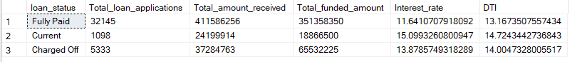

with respect to the loan status instead of looking good loan and bad loan for all the loan status how the bank is performing in month to date

select

loan_status,

sum(loan_amount) AS MTD_Total_funded_amount,

sum(total_payment) AS MTD_Total_amount_received

from bank_loan_data

where month(issue_date)=12

group by loan_status

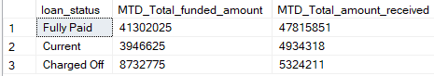

DASHBOARD 2:Overveiw

CHARTS

1. Monthly trends by issue date

select month(issue_date) AS Month_number,

datename(month, issue_date)AS Month_name,

count(id) AS Total_loan_applications,

sum(loan_amount) AS Total_funded_amount,

sum(total_payment) AS Total_received_amount

from bank_loan_data

group by month(issue_date), datename(month,issue_date)

order by month(issue_date)

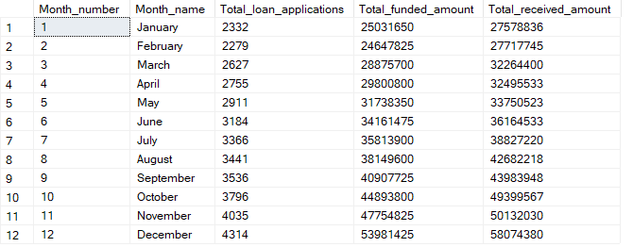

1. Regional analysis by state

select address_state,

count(id) AS Total_loan_applications,

sum(loan_amount) AS Total_funded_amount,

sum(total_payment) AS Total_received_amount

from bank_loan_data

group by address_state

order by sum(loan_amount) desc

1. Long term analysis

select term,

count(id) AS Total_loan_applications,

sum(loan_amount) AS Total_funded_amount,

sum(total_payment) AS Total_received_amount

from bank_loan_data

group by term

order by term



1. Employee length analysis

select emp_length,

count(id) AS Total_loan_applications,

sum(loan_amount) AS Total_funded_amount,

sum(total_payment) AS Total_received_amount

from bank_loan_data

group by emp_length

order by count(id) desc

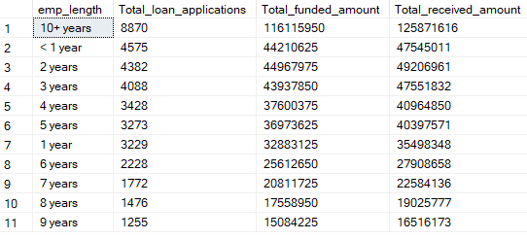

5.Loan purpose breakdown

select purpose,

count(id) AS Total_loan_applications,

sum(loan_amount) AS Total_funded_amount,

sum(total_payment) AS Total_received_amount

from bank_loan_data

group by purpose

order by count(id) desc

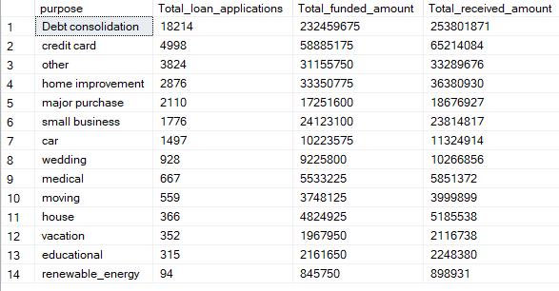

1. Home ownership analysis

select home_ownership,

count(id) AS Total_loan_applications,

sum(loan_amount) AS Total_funded_amount,

sum(total_payment) AS Total_received_amount

from bank_loan_data

group by home_ownership

order by count(id) desc

